SchoolsPlus serves students, families
http://thechronicleherald.ca/community/south-shore/1211150-schoolsplus-serves-students-families#.VRyKpFIhTqY.mailto

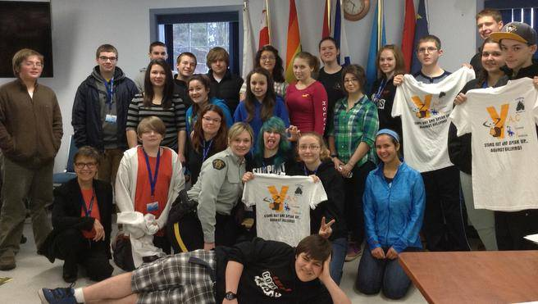
The Youth Advisory Committee includes student members of the group, along with Shirley Burris, SchoolsPlus Facilitator. Contributed
Since 2008 South Shore SchoolsPlus has operated in the South Shore Regional School Board. Originally started as a pilot program in the Chester area, South Shore SchoolsPlus has expanded to serve all Queens County schools, the New Germany family of schools, Bridgewater town schools, and continues with the Chester area family of schools.
South Shore SchoolsPlus facilitates the delivery of services to students and families in their local school. These include mental health, addictions, public health and justice services and programs through partnerships with these government agencies along with other community groups. The team works to break down barriers to access to programs and services for students and their families.
Currently South Shore SchoolsPlus operates over 40 youth, community and school-developed programs. These programs respond to needs identified by youth, families and communities. They often are developed by the students themselves with the support of the South Shore SchoolsPlus team.
One such initiative is the Lunenburg County RCMP Youth Advisory Committee (YAC), a group of 31 students from middle level and high schools who come together with members of the South Shore SchoolsPlus team to address issues such as bullying, sexual assault and substance abuse.
The YAC demonstrates individual and team leadership with their creation of public service announcements and videos addressing cyberbullying, bullying, sexting and drug awareness. Not a group to shy away from difficult topics, the YAC has presented to parent and community groups, designed posters for awareness campaigns and encouraged ongoing conversations in their schools.
The YAC recently received a group Lieutenant Governor’s Respectful Citizenship award for their positive contributions to their school communities. Award recipients are recognized for their respectful and responsible relationships and their work to create a safe and inclusive environment.
South Shore SchoolsPlus Outreach Workers are in schools daily, assisting students and families to succeed in school, as families and within the community. Work done by the South Shore SchoolsPlus team is multi-faceted but all comes together to help students and families with various supports and services.

